
Dashboard Design

Date | 29 July 2026
Team ID | Rithika C
Project Name | India's Agricultural Crop Production Analysis (1997–2021)
Maximum Marks | 5 Marks

Activity 1: Interactive and Visually Appealing Dashboards
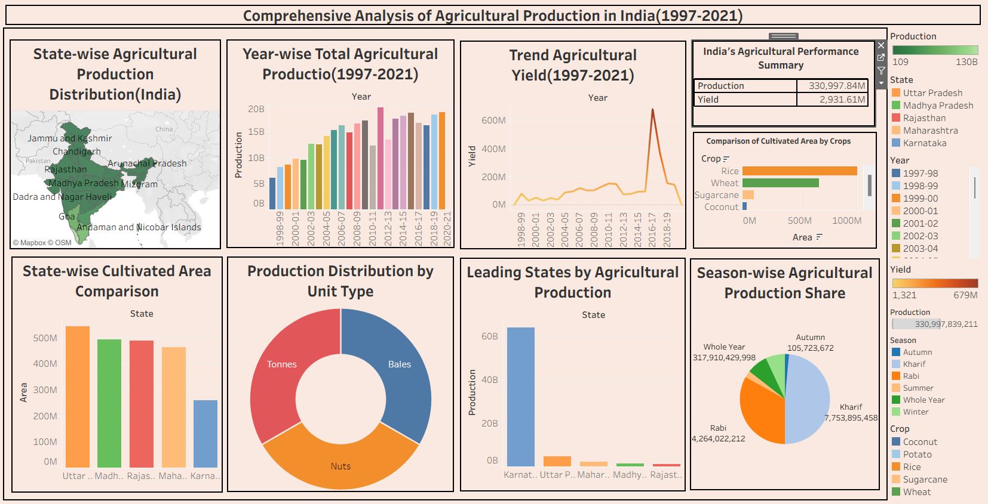
The core design principles—including a Clear and Intuitive Layout, Consistent Color Scheme, Interactive Filters, KPI-Based Visualization, Geographical Representation, and Responsive Dashboard Design—have been applied to create the India's Agricultural Crop Production Analysis Dashboard. Below are the key outcomes and insights presented through the interactive visualization interface:
- Agricultural Performance Overview (KPI Cards): The dashboard provides a comprehensive overview of India's agricultural production by displaying key indicators such as Total Agricultural Production, Total Cultivated Area, Number of States/UTs, Number of Crops, and Number of Seasons, enabling users to quickly understand the overall agricultural landscape.
- Geographical Production Distribution (Map Chart): The interactive map visualizes agricultural production across different Indian states, allowing users to identify high-producing and low-producing regions while understanding the geographical distribution of agricultural activities.
- Crop Cultivation Analysis (Cultivated Area by Crops): The crop-wise cultivated area bar chart compares the agricultural land allocated to different crops, helping users identify the most extensively cultivated crops and evaluate crop cultivation patterns.
- Regional Agricultural Comparison (State-wise Agricultural Production & Cultivated Area): The comparative bar charts rank states based on cultivated area and total agricultural production, enabling effective evaluation of regional productivity and agricultural performance across India.
- Historical Production Trend Analysis (Year-wise Agricultural Production): The line chart illustrates agricultural production trends from 1997 to 2021, enabling users to observe annual growth, production fluctuations, and long-term agricultural development over the study period.
- Seasonal Production Distribution (Season-wise Agricultural Production Share): The seasonal production visualization highlights the contribution of each agricultural season to total production, helping users understand seasonal cultivation patterns and their impact on agricultural output.
- Production Distribution Analysis (Production Unit Type): The production distribution chart provides a visual representation of production categories, offering additional insights into the composition of agricultural production measurements within the dataset.
- Interactive Data Exploration: By implementing interactive filters for State, Crop, Season, and Crop Year, users can dynamically explore agricultural production patterns, compare different regions and crops, and perform detailed analysis through an intuitive Tableau dashboard.

Activity 2: Live Deployment Link
The completed interactive dashboard and Tableau Story have been published on Tableau Public for public access.
Tableau Public Dashboard Link:
https://public.tableau.com/app/profile/rithika.c3948/viz/IndiasAgriculturalAnalysisDashboard/Dashboard1

